**Agenda of Today’s Meeting (05th-March’25)**

**Key points to be discussed:**

1. **Manage Devices:**

* *We have configured the* ***QNO-C8083R*** *camera in the SPEC premises and tested API responses using the provided* ***Sunapi JSON View.***
* *During testing, we made an API call to the* ***"deviceinfo"*** *endpoint and found that the response does not include all the required information needed to sync with the Figma design for the* ***"Manage Device"*** *functionality.*
* *We need your assistance in resolving this issue. Please find the attached screenshot for your reference:*

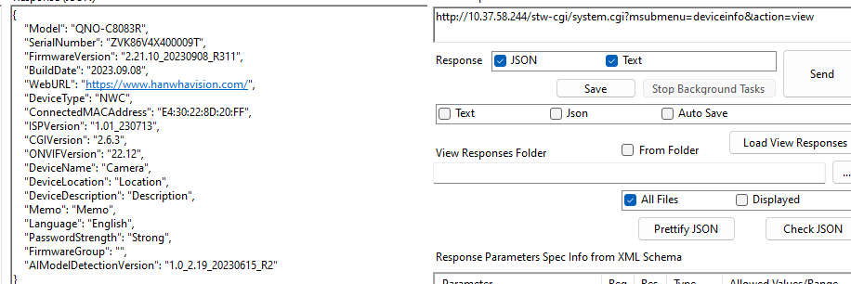

**

* In the above API named “deviceinfo”, we observed that we are unable to make an API call without providing a **username and password**.
* This raises a concern: **How will we fetch associated device information when the user enters the IP address of a specific device while adding a new device in the BI Dashboard Web Application?**

* Do we need to call any other API to retrieve the device details without authentication, or is there an alternative approach? **Please assist us on this!**

**Pending Items for Bala & Team:**

1. **Source Code Access:** When do you anticipate providing the source code for both existing applications?
2. **Additional Camera Link & AI Box:** When can we expect an additional camera link for online testing, including the AI box? This will help us test the camera API responses.
3. List of Functionalities to be implemented in the **Map Plan**.